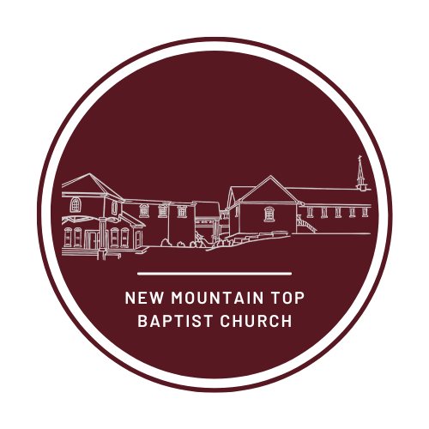

Application Packet & Guidelines

New Mountain Top Baptist Church is dedicated to helping young people to attend and succeed in the educational arena. The belief that “every child can and will learn with the proper educational resources” is echoed throughout the church.
The Mission of New Mountain Top Baptist Church Scholarship Committee is to BUILD a collaborative network of members and supporters to IMPROVE the quality of education through their generosity in giving.

The Vision of New Mountain Top Baptist Church Scholarship Committee is empowering the youth in the designated area with need-based educational resources.

The Purpose of the New Mountain Top Baptist Church Scholarship Program is to provide scholarships to deserving college students intending to pursue a course of study at either a two-year or four-year educational institution.

For 2023, the NMT Scholarship Program individual awards will be based on Funds Raised and Dollars for Scholars Scholarship Amount. NOTE: Scholarship funds will be awarded to the student upon evidence of registration in an accredited higher educational institution.

Criteria and eligibility (New Mountain Top Scholarship Program)
- Applicant must be a member of New Mountain Top Baptist Church.
- Applicant must be currently attending a higher educational institution in the year of the award. (Verification of enrollment must be presented before any funds will be disbursed)
- Applicants must be willing to attend a scholarship orientation with the NMT Scholarship Team (if needed).
- Must have graduated from high school on or after 2018

General Instructions
- DEADLINE for scholarship applications is December 18, 2023, 5:00 p.m. (No exceptions).
- Refer to application process below for a list of the supporting documents needed (i.e., evidence of enrollment and/or GPA, etc.) Incomplete applications will not be considered.
- If any question does not apply to you in this application, please put N/A in the space.
- Type and/or print legibly. Illegible applications will not be considered.

If you have any questions about the application, please call the NMT Office at 770-942-6855

Application Process:
Applicant must submit the following items:
- Completed application form (if handwritten, please print legibly)
- An official and recent transcript or verification of enrollment with cumulative grade point average.
- Black and White or Color Photo- can be a head shot or full body.

Deadline for the application is: December 18, 2023 @ 5:00 p.m.
Applications postmarked after this date will not be considered.

Please mail OR submit the application in person to:
New Mountain Top Scholarship Committee
7822 Conner Road
Winston Ga 30187
770-942-6855

New Mountain Top 2023 Scholarship Application

 |  |  |  |  |  |  |  | Date of Application:
Please type or print your answers. If application is illegible it will be returned to you.
1. | Last Name: |  | First Name:
2. | Mailing Address:  Street: _________________________________________________________  City: State: ZIP:
3. | Daytime Telephone Number: ( )
4. | Date of Birth: Month Day Year (Optional)
5. | Email Address:
6. | Current College/University: |  |  |  |  |  |  |  | Number of years attended:
7. | I will be attending the following school in the Fall of 2024: ___________________________________  Proof of acceptance or current student enrollment from the above school is required prior to funds being released.
8. | I will be entering the above-mentioned school as a: (Circle one)  Freshman Sophomore Junior Senior
9. | Grade Point Average (GPA): __________(On a 4.0 scale) Optional if applicable
10. | School Activities:
11. | Name & address of parent(s) or legal guardian(s): Use the reverse side of application if you need more space.  Name (s) ______________________________________________________________________________  Street: ___________________________ City:_____________________ State: ______ ZIP:_____________  Home phone of parents or legal guardians:
12. | Name and city of high school attended: |  |  |  |  |  | Number of years attended:
13. | List the name of other colleges you have attended. |  |  | Year  Began | Year  Ended | Year  Graduated  (If applicable) |  |  |  | Type of Degree  Received  (If applicable)
 | A.
 | B.
 | C.
14. | What area or specialty do you plan to major in as you continue your education?

15. | List your academic honors, awards and membership activities:
16. | List your community service activities, hobbies, outside interests, and extracurricular activities:

17. | Church Service- Please list the NMT ministries in which you have participated (use additional sheets if necessary)

18. | A. The following items must be attached to this application in order for the application to qualify to be reviewed by the scholarship committee.  B. Your application will not be considered if these items are not attached to this application. (No exceptions.)  C. Circle “YES” or “NO” to be sure you have attached each item as required.
 | YES | NO | Completed application. All questions are answered completely.
 | YES | NO | Proof of college enrollment. A copy of your college transcript letter is required for receipt of funds.
 | YES | NO | Most recent photo

STATEMENT OF ACCURACY

I hereby affirm that all the above stated information provided by me is true and correct to the best of my knowledge. I also consent that my picture may be taken and used for any purpose deemed necessary to promote the New Mountain Top Baptist Church’s scholarship program.

I hereby understand that if chosen as a scholarship recipient, according to New Mt Top Baptist Church Scholarship policy, I must provide evidence of enrollment/registration at the post-secondary institution of my choice before scholarship funds can be awarded.

Signature of the scholarship applicant: _________________________________ Date: _______________________

Signature of applicant’s guardian/parent: _________________________________ Date: ___________________
“A Growing church for Growing People”

